# 6U 450MM 19" DATA RACK WALL CABINET - BLACK | 6U DATA CABINET

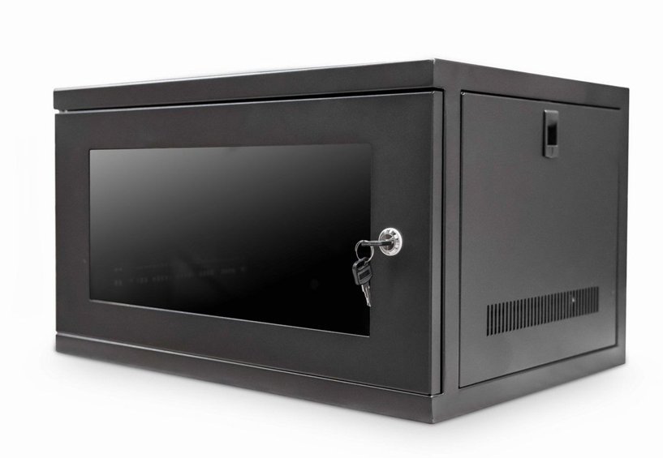

# Descrption:

The new **CAB-W6U-EL450** is a feature-rich, **6U** high wall mount cabinet that allows all networking, PBX, A/V and home automation to be installed within its  universal standard 19-inch vertical support rails.

With an extra 450mm deep form-factor, the majority of entry to medium range networking hardware can be installed with ease, as well of course passive networking hardware including patch panels, cable management, PDUs and even rack-mount fan trays.  
Fully built straight from the box, the **CAB-W6U-EL450 (6U Data Cabinet)** features a front and of course reversible lockable door, removable side panels for ease of equipment access and rear vertical profiles for secure equipment fixing.

Equipped with ventilation slots for increased equipment airflow and of course easy, single person installation makes the **CAB-W6U-EL450** the ideal choice for all your SME installations.

# SPECIFICATIONS:

6U high 550W 450D

ETSI 19” front/rear profiles  
  
Lockable glass door, reversible if required  
  
Wall mountable with removable side panels  
  
Power-coated BLACK and robust grey finish  
  
Easy-to-install wall deployment - pre built  
  
Supplied with a bag of M6 fixings*

# TECHNICAL INFO:

SKU/MPN: CAB-W6U-EL450

EAN: 8400800016119

Weight: 11.3Kg

Dimensions: 550 (width) x450(depth) x320 mm (height)

# FILES

[Datasheet - CAB-W6U-EL450](https://cdn.shopify.com/s/files/1/0071/2337/0043/files/CAB-W6U-EL450.pdf?43)